QUESTION 1. (Start on a new sheet of paper) MARKS

a) If 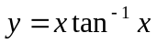, find . 2

b) If 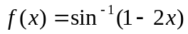, show that 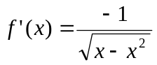. 3

c) P(x) is an odd polynomial of degree 3. It has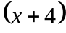 as a factor and, 3
when it is divided by 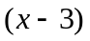, the remainder is 21. Find P(x).

d) By making the substitution 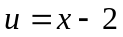, evaluate 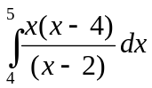 4

C
A
D
B
O
xº
QUESTION 2. (Start on a new sheet of paper)

a) The points A, B, C and D lie on the 3
circumference of a circle centred at O.
CD is a diameter of the circle and AB
is parallel to CD. 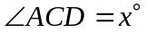.
Find an expression for 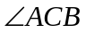 in
terms of x.

b) Use the method of mathematical induction to show that the
expression 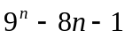 is divisible by 64 for all integers 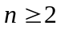. 5

c) i) Given that 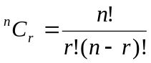, show that 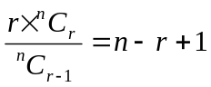 1

- Hence show that :
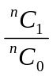 + 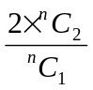 + 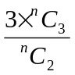 + … + 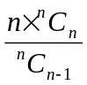 = 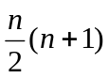. 3

QUESTION 3. (Start on a new sheet of paper) MARKS

a) Evaluate the definite integral 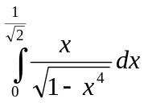 by using the substitution 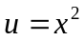. 4

b) The point P(2ap,ap²) is on the parabola 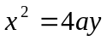 and a straight line OQ is drawn
through the vertex parallel to the tangent at P. This line meets the parabola
again at Q and the tangent to the parabola at Q meets the tangent at P in R, as
shown in the diagram.

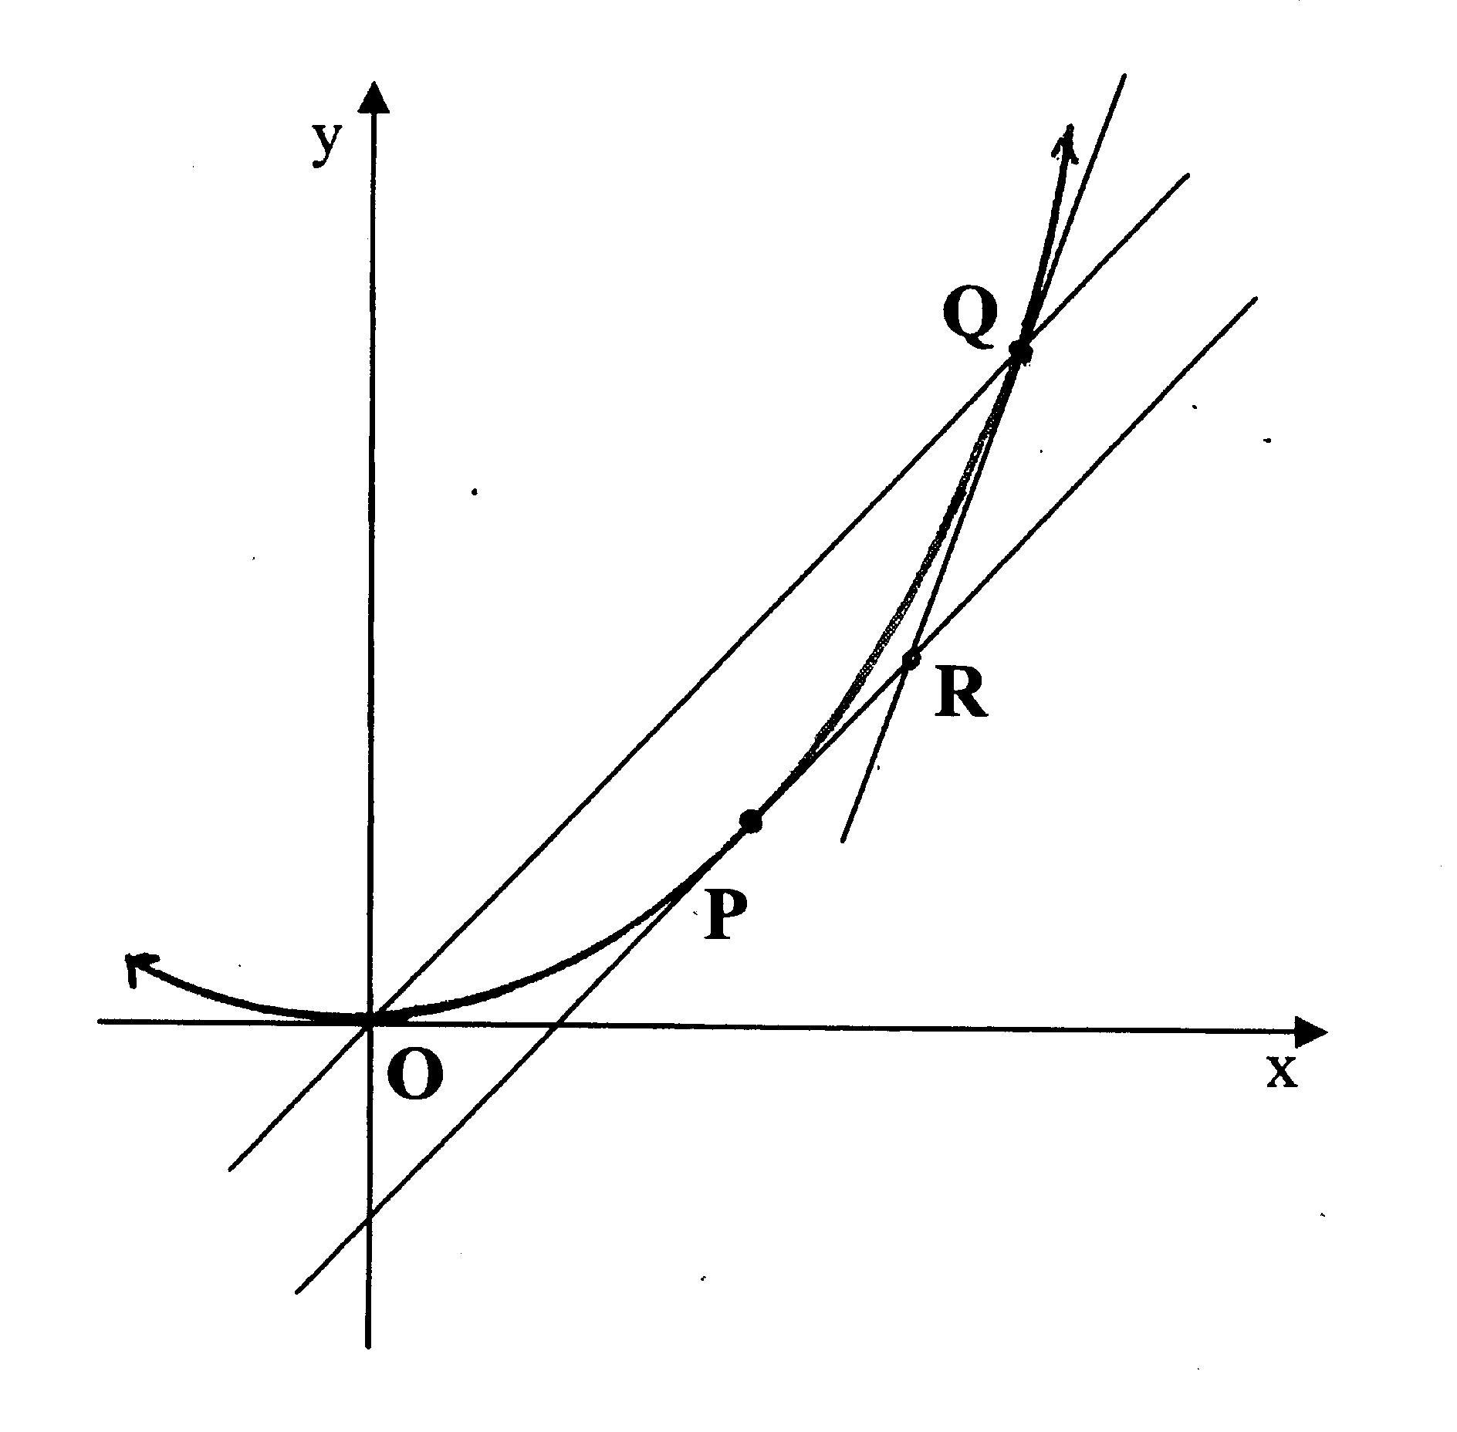

You are given that the tangent at P has equation 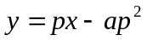.

  - Write down the equation of the line OQ. 1

  - Find the coordinates of Q in terms of a and p. 2

  - Show that the equation of the tangent at Q is 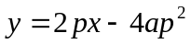. 1

  - Find the coordinates of R. 2

  - Show that, as P varies on the parabola, R moves on another parabola 2
whose equation is 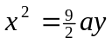.

QUESTION 4. (Start on a new sheet of paper) MARKS
a) Consider the function 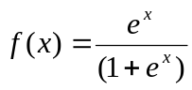.
- Find 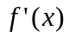 and deduce that f(x) is increasing for all x. 2

- State the range of f(x). 1

- Find the inverse function 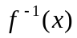 2

- Draw  and 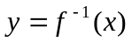 on the same diagram. 2

b) A particle moves in a straight line on the x axis. At time t its velocity is v
and its acceleration is a.

- If 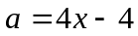 and initially 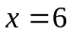 and 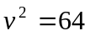, show that 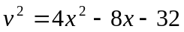. 2

- Use this expression for v² to find the possible values of x. 1

- Describe the motion of the particle if 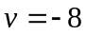 initially. 2

QUESTION 5. (Start on a new sheet of paper)

a) A particle moves in a straight line with displacement in centimetres from
the point  at time t seconds given by 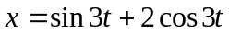 for 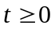.
i) Express x in the form 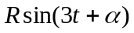 where R>0 and 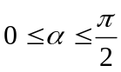. 2
ii) Show that the motion is simple harmonic. 1

iii) Write down the period of motion. 1

- Find at what time, to the nearest tenth of a second, the particle
first reaches 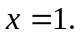 2

b) Fred deposited $20,000 at the beginning of January into an account which paid
interest at the rate of 0.5% per month compounded monthly. He withdrew $50
each month from the account each month, immediately after the interest was paid.

i) How much money was in the account immediately after the first withdrawal ? 1

ii) Show that, after making the n^{th} withdrawal, his account balance is given
by the expression 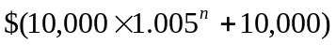 3

iii) Find the number of months it will take for his account balance to be $50,000 2

QUESTION 6. (Start on a new sheet of paper) MARKS
a) Find the term independent of x in the expansion of 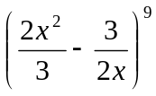. 3

b) An aeroplane, A, flying at a height of 2000m observes a stationary blimp, B, at
a height of 3200m drop an object. As the object is dropped, the plane fires a
projectile towards it at a speed of 240m/s and at an angle θ to the horizontal.
The horizontal distance between the plane and the blimp is 3600m at the time
that the projectile is fired.
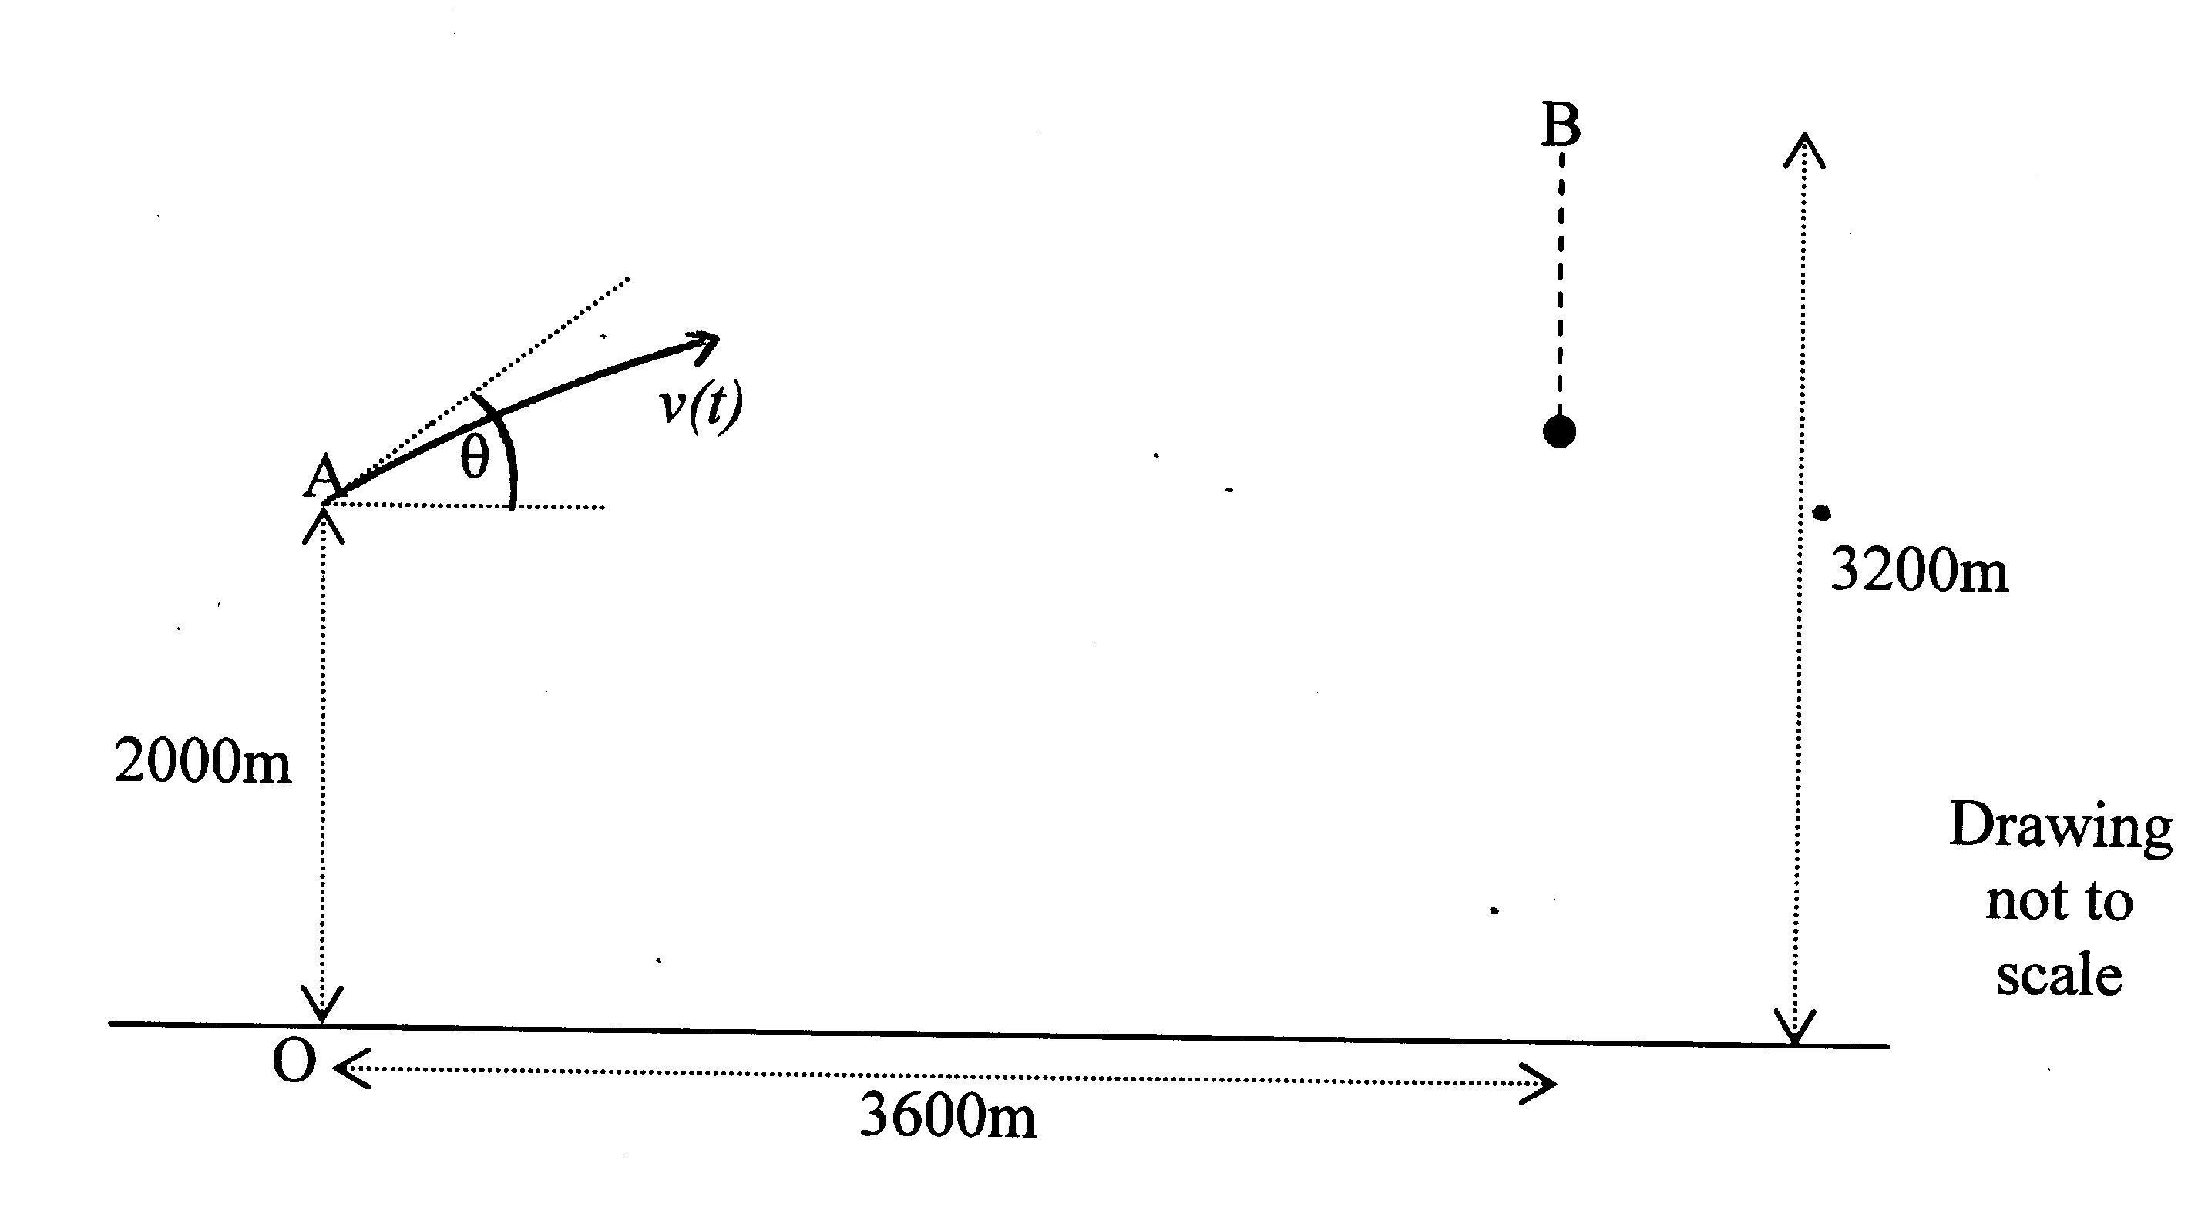

The origin of coordinates, O, is taken to be the point on the ground below A.
The particle’s coordinates at time t (secs) are given by : 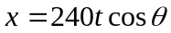,
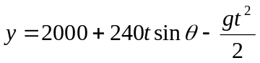
The coordinates of the dropped object at time t are : 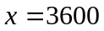 ,
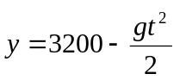
(You may use g=10m/s²)

i) What is the angle θ at which the projectile must be fired to intercept the 3
object, and how long does it take to reach it?

ii) At what height does the projectile intercept the object? 1

c) A man notices two towers, one due North and one in a direction NθE (i.e. at an
angle θ east of north). The angle of elevation β of both towers is the same but
the height of one tower is twice the height of the other. Show that
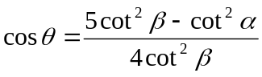 5
where α is the angle of elevation of the top of the taller tower from the top of
the shorter.
QUESTION 7. (Start on a new sheet of paper) MARKS

a) A group of four contestants for a quiz game are to be selected at random from a
class of eight girls and five boys.

i) What is the probability that the team comprises three girls and one boy? 2

ii) Find the probability that there are more girls chosen than boys. 2

b) A water trough takes the shape of a hollow semi-circular prism with length l and
radius r. It is placed on horizontal ground and filled with water. The surface of
the water is at a distance h below the top of the trough, as shown in the diagram.

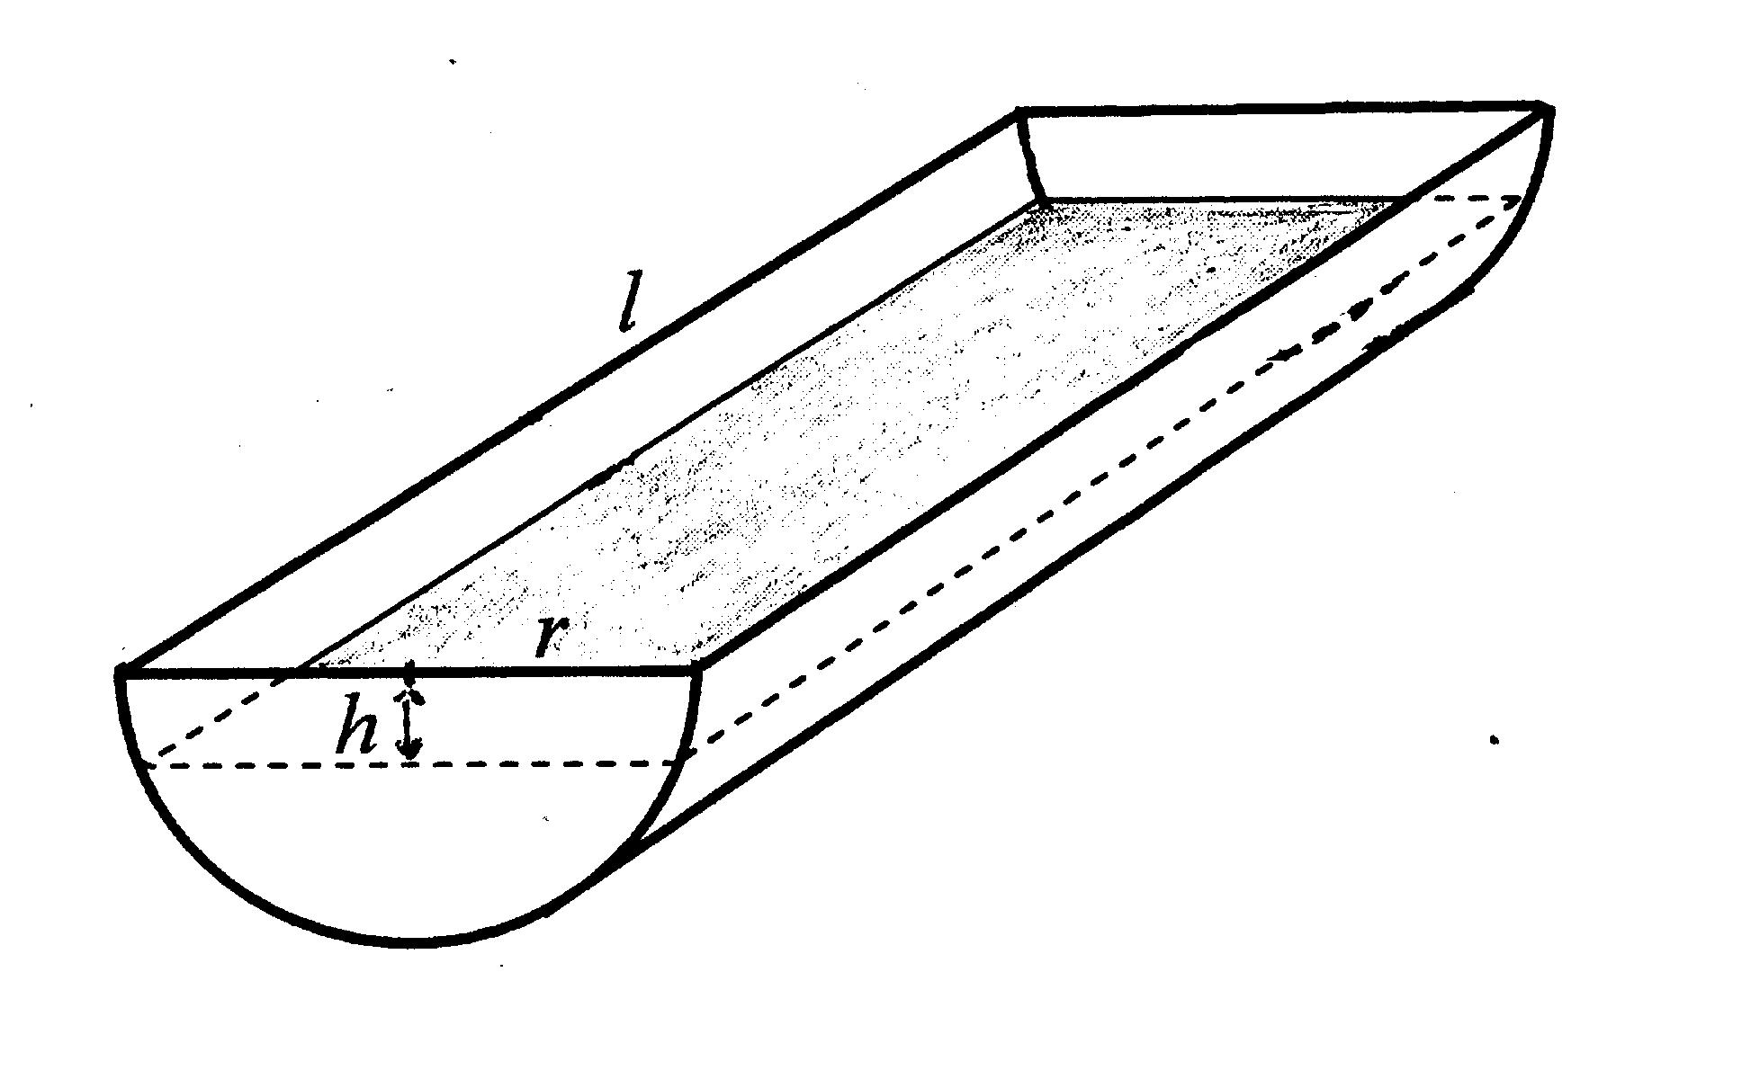
- Show that the area A of the flat surface area of water is given by
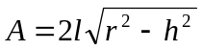 2

ii) Show that the volume V of water in the trough is given by
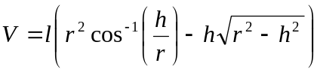 2
- If the water level is falling, show that 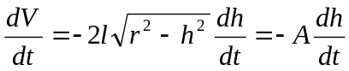. 3
- On a sunny day, the rate of evaporation at any time (and hence 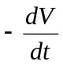) is
proportional to A. Show that the water level falls at a constant rate. 1

END OF THE PAPER

